New Entry Test
Name
Marine Cadet or Blue Jacket
Date
Score

Section 1 – Unit
- Please describe below what you would do in the event of a fire

- Please draw a line between the following names and their role within the unit
2LT Craig Clarke | Senior Divisional Officer – Blue Jackets
SGT Thomas Taylor | Detachment Sergeant Major
LT Matthew Taylor | Executive Officer
SGT Darren Matthews | Commanding Officer
SGT Derry Hand | OiC Junior Divisions
PO Ieuan Male | Detachment Commander

- Explain below what you must do when the still is piped?

- Draw the Ensign

- Draw the Preparative Pennant

- Describe the Colours & Evening Colours routine

- What pipe is called after the still?

Section 2 – Ranks & Rates
- Complete the below tables
Blue Jacket Cadets |  | Marine Cadets
Badge | Rank | Badge | Rank
 | New Entry |  | Recruit
 | Cadet | NO BADGE
 |  | NO BADGE | MC1
 | Able Cadet
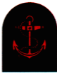 |  |  | Corporal
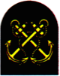 | PO Cadet

STAFF
Blue Jacket Staff |  | Marine Staff
Badge | Rank | Badge | Rank
NO BADGE | CI | NO BADGE | CI
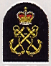 | Petty Officer
 |  |  | Colour Sergeant
 | WO2
 |  |  | WO1

OFFICERS
Blue Jacket Officers |  | Marine Officers
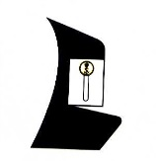 |  | 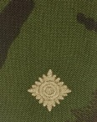 | 2nd Lieutenant
 | Sub Lieutenant
 | Lieutenant |  | Captain
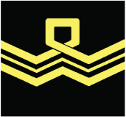 | Lieutenant Commander | 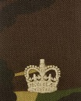 | Major
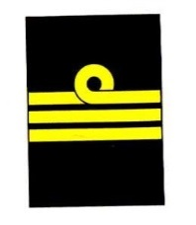 | Commander | 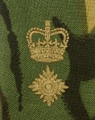 | LT Colonel
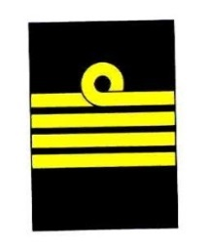 | Captain | 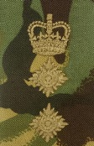 | Colonel

Section 3 – Complete the below table with the correct times
12 Hour Clock | 24 Hour Clock
6pm
 | 1300hrs
3pm
 | 2300hrs
7am
 | 0900hrs

Section 4 – General Sea Terms
- Draw a line between the word and its meaning

Galley | Rubbish
Main Deck | Toilets
Heads | Kitchen
Port | Right side of ship
Gash | Deck where the Ensign is sighted
Starboard | Left side of Ship

