Marine Cadet Staff

Phase Book

Phase 2

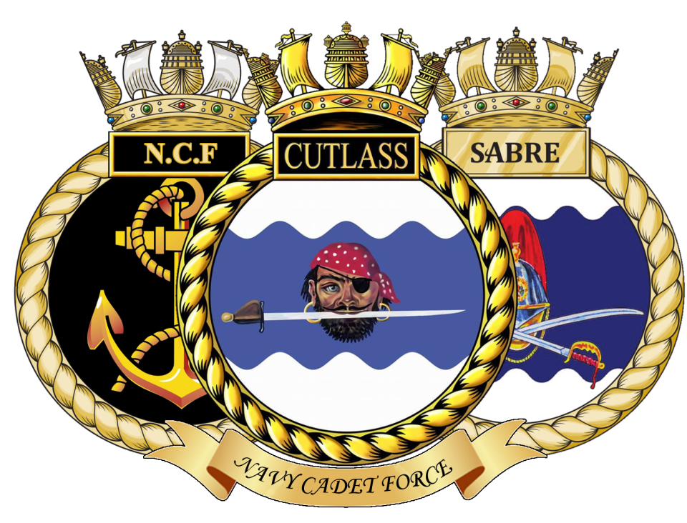

SGT to CSGT

Syllabus Contents

Ph2.1 | Weapon Training – L98A2 rifle
Ph2.2 | Map Reading
Ph2.3 | Seamanship
Ph2.4 | Royal Marines History and Traditions
Ph2.5 | Squad Drill
Ph2.6 | Armed Drill
Ph2.7 | Rank Recognition in the Army and Royal Air Force
Ph2.8 | Camp craft
Ph2.9 | Communications
Ph2.10 | Orders, QBO’s & Warning Orders
Ph2.11  Ph2.12 | Field Craft  Instructional Techniques
Ph2.13 | Exercise Planning

Marine Cadet Detachment
Phase 2 Training

 | MODULE : WEAPON TRAINING – L98A2 RIFLE |  |  | Ph2.1
CONTENTS:

- Safety precautions and rules for handling weapons at all times.

- Stripping, cleaning and reassembling. Name the parts of a L98.

- Fitting the sling.

- Sight setting, aiming and holding.

- Correct firing position for aiming and firing.
- Lying
- Kneeling
- Standing
- Sitting
- Squatting
- Magazine loading and unloading.

- Correct drill for loading and unloading.

- Correct drill for making safe.

I. Marksmanship Principles

Sign and date on completion of each subject
a | e | i
b | f | j
c | g | k
d | h | l

a | e | i
b | f | j
c | g | k
d | h | l

CO/OIC Notes:

Assessment Completed Date |  | Assessment Grade | Assessor Signed

Marine Cadet Detachment
Phase 2 Training

 | MODULE : MAP READING |  |  | Ph2.2
CONTENTS:

- The grid system and the correct way to give a six figure grid reference.

- Relief and contours

- Introduction to the Silva compass

- Setting a map and finding north; points of the compass.

- Map scales and measuring distances.

- Description of ground – intervisibility & tactical importance.

- The Silva Compass - Application to the map; Setting a Bearing.

- Bearings and Back Bearings.

- The use of a Protractor: position finding; Measuring a Bearing.

- Compass errors and Magnetic deviation; Resections.
Sign and date on completion of each subject
a | e | i
b | f | j
c | g
d | h

CO/OIC Notes:

Assessment Completed Date |  | Assessment Grade | Assessor Signed
Marine Cadet Detachment
Phase 2 Training

MODULE : SEAMANSHIP |  |  | Ph2.3
CONTENTS:

- Types of boats in common use within the NCF.

- Safety measures and safety precautions in boats..

- Coiling a rope; belaying a rope, faking & cheesing.

- Correct method of casting off; heaving a line; tying up and making fast.

- Explain and teach the following:
- Clove hitch
- Bowline
- Round turn & 2 half hitches
- Figure of 8
- Reef Knot

- Practical boat work afloat.
Sign and date on completion of each subject
a | e
b | f
c
d

CO/OIC Notes:

Assessment Completed Date | Assessment Grade | Assessor Signed

Marine Cadet Detachment
Phase 2 Training

MODULE : ROYAL MARINES HISTORY AND TRADITIONS | Ph2.4
CONTENTS:

- To have a good knowledge of Royal Marine history and traditions including knowledge of Battles and VC winners.

Sign and date on completion of each subject
a

CO/OIC Notes:

Marine Cadet Detachment
Phase 2 Training

MODULE : SQUAD DRILL |  |  | Ph2.5
CONTENTS:

- In quick time – marching in line; eyes left and right; eyes front.

- Sizing

- Attention : Stand at Ease : Stand Easy : Proving : Interval Drill.

- Fall in : Dressing : Numbering : Fall out : Dismiss.
- At the halt : right, left and about turn : right / left incline.

- Step off in quick time : Marching in quick time : Halting.

- Mark time in quick time : Forward : Halting.

- Paces forward : Paces sideways : Paces to the rear.
- About turn on the march in quick time.

- Right and left wheel on the march in quick time : Forward.

- Left and right turn in quick time.

- Reporting to and saluting an officer. Why we salute officers

Sign and date on completion of each subject
a | e | i
b | f | j
c | g | k
d | h | l
CO/OIC Notes:

Assessment Completed Date | Assessment Grade | Assessor Signed
Marine Cadet Detachment
Phase 2 Training

MODULE : ARMED DRILL |  |  | Ph2.6
CONTENTS:
- Attention; stand at ease; stand easy.

- Slope arms from the shoulder; shoulder arms from the slope

- Right and left dress at the shoulder arms.

- Present arms from the slope/shoulder; slope/shoulder arms from the present.

- For inspection port arms from the shoulder; ease springs.

- Change arms from slope & shoulder

- Ground arms & take up arms from slope/shoulder (At the halt)

- High port arms from slope; slope arms from the high port

- On guard from the slope; slope arms from the on guard

- Trail arms from the slope/shoulder; slope/shoulder arms from the trail

- Saluting with a rifle.

- All above should be carried out in quick time and at the halt unless otherwise stated
Sign and date on completion of each subject
a | e | i
b | f | j
c | g | k
d | h | l
CO/OIC Notes:

Assessment Completed Date | Assessment Grade | Assessor Signed

Marine Cadet Detachment
Phase 2 Training

MODULE : RANK RECOGNITION IN THE ARMY AND  ROYAL AIR FORCE | Ph2.7
CONTENTS:

- Ranks & Rates of the NCF

- The commissioned ranks in the Army and Royal Air Force.

- Comparison of these ranks with the RN and RM commissioned ranks.

- The non-commissioned ranks in the Army and Royal Air Force.

- Comparison of these ranks with the RN and RM non-commissioned ranks.
Sign and date on completion of each subject
a | d
b | e
c

CO/OIC Notes:

Marine Cadet Detachment
Phase 2 Training

MODULE : CAMPCRAFT | Ph2.8
CONTENTS:

- The techniques for personal survival in adverse weather. Discuss the risk of EXPOSURE and mention the ‘buddy’ system as a means of early detection of exposure symptoms.

- The construction of a bivouac.

- Essential clothing, supplies and equipment vital for even the simplest of expeditions.

- The correct use of a hexamine cooker. Discuss personal field cookery.

- Field hygiene and sanitation

- Packing and carrying a load correctly.

- The Country Code.

- The basic Rescue Procedures Constructing a makeshift stretcher; roping a casualty to a Stretcher; carrying a casualty by alternative methods; traversing rough or broken ground whilst carrying a stretcher; crossing an obstacle with a casualty on a stretcher.

Sign and date on completion of each subject
a | d | g
b | e | h
c | f

CO/OIC Notes:

Marine Cadet Detachment
Phase 2 Training

MODULE : COMMUNICATIONS | Ph2.9
CONTENTS:

- The phonetic alphabet.

- Making a verbal report.

- Basic VP (voice Procedures)

Sign and date on completion of each subject
a
b
c

CO/OIC Notes:

Marine Cadet Detachment
Phase 2 Training

MODULE : Orders, QBO’s & Warning Orders | Ph2.10
CONTENTS:

a The composition content and the process of QBO’s

b The composition content and the process of Warning Orders

c The composition content and process of full set of Orders

d The orders process including headings

`Sign and date on completion of each subject

a | c
b | d

CO/OIC Notes:

Marine Cadet Detachment
Phase 2 Training

MODULE : FIELD CRAFT | PH2.11
CONTENTS:

- Camouflage and concealment including why things are seen.
- Basic crawls and moving with/without a weapon.
- Movement by night.
- Observation by day and by night. How to search ground; identifying sounds at night.
- Selecting lines of advance; stalking
- Elementary obstacle crossing.
- Section formations and field signals
- Six section battle drills.
- Fire control orders (F.C.O.)
- Judging distance / target indication
- Harbour Areas and Routine
- models in detail and relief
- 3 types of patrols
- Duties of a Sentry; Sentries at night; Section in Defence
- Ambushes

Sign and date on completion of each subject
a | f | k
b | g | l
c | h | m
d | i | n
e | j | o

CO/OIC Notes:

Marine Cadet Detachment
Phase 2 Training

MODULE : INSTRUCTIONAL TECHNIQUES |  |  | Ph2.12
CONTENTS:

- Explain, demonstrate and practice the basic teaching techniques to be employed when instructing Cadets.

Sign and date on completion of each subject

a

CO/OIC Notes:

Assessment Completed Date | Assessment Grade | Assessor Signed

MODULE : EXERCISE PLANNING |  |  | Ph2.13
CONTENTS:

- Preparation of an administrative plan.

- Preparation of an action plan.

- Correct method of Briefing / De-briefing.

Please sign and date on completion of subject

a | c
b

CO/OIC Notes:

Assessment Completed Date | Assessment Grade | Assessor Signed
Marine Cadet Detachment
Phase 2 Training

Marine Cadet Detachment
Phase 2 Training
MODULE : CO/OiC Recommendation | Ph2.13
Prerequisites

- Must be a substantial SGT for a minimum of 4 years or hold recognised prior experience teaching in the cadet forces.
- Must play a committed active role within the respective unit and have upheld the unit’s policies and procedures.

Recommendation

Please write your recommendation below:

CO/OiC Name: | Rank:
Signed: | Date:

