Marine Staff

CI to SGT

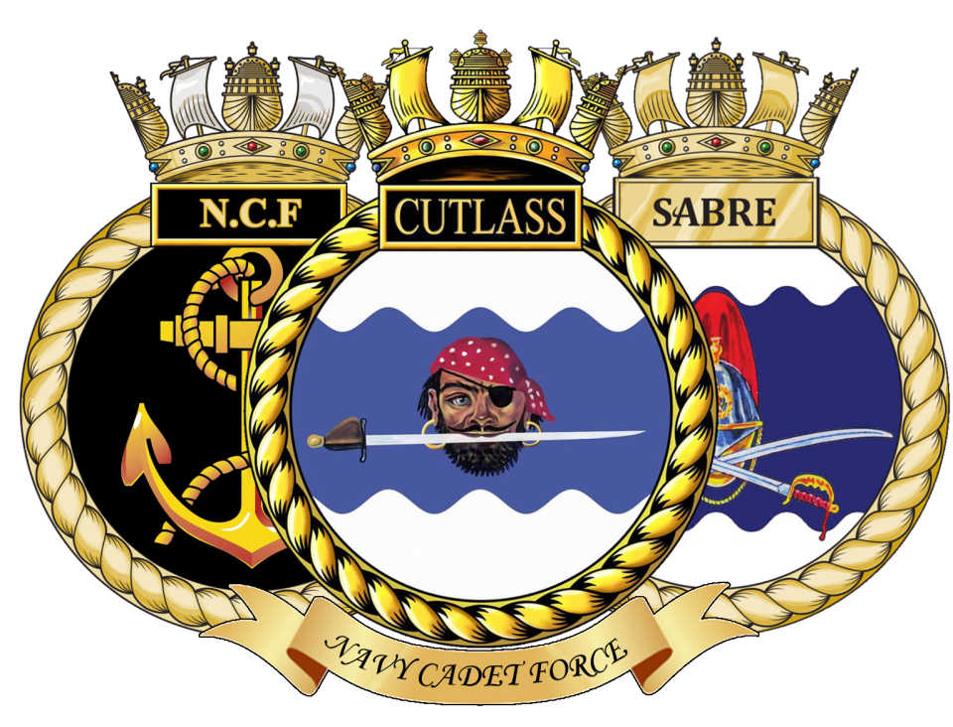

Syllabus Contents

Ph1.1 | Unit routine and everyday ceremonial
Ph1.2 | Basic seamanship
Ph1.3 | Naval terms and customs
Ph1.4 | Basic history of the Royal Marines
Ph1.5 | Basic foot drill
Ph1.6 | Ranks and Rates
Ph1.7 | Basic Communications
Ph1.8 | Uniform cleaning techniques
Ph1.9 | Basic weapon training – L98A2 rifle
Ph1.10 | Basic map reading
Ph1.11 | Basic arms drill at the halt (basic SA80 rifle)
Ph1.12 | Basic field craft
Ph1.13 | Instructional Methods

Marine Staff

MODULE: UNIT ROUTINE AND EVERYDAY CEREMONIAL | Ph1.1
CONTENTS:

- Explain the history and importance of Colours and Evening Colours ceremonies.

- Witness the Colours ceremony.

- Explain the parts of the mast, the use of the Preparative pennant and the history and use of the Church Pennant.

- Explain the routine duties of the following:

- Signalmen: Give a brief explanation of Ensign and the Preparative Pennant.

- The Guard: When and how used; how it is made up and commanded.

- Quartermaster and Side Party: Use of deck log; reports to Duty Officer; running the Unit Routine; Visitors to the Unit, etc.

Special Dutymen: including Corporal of the gangway.

Sign and date on completion

A | d i)
B | d ii)
C | d iii)

CO/OIC Notes:

Marine Staff

MODULE: BASIC SEAMANSHIP |  |  | Ph1.2
CONTENTS:

- Parts of a Ship – Describe:

- Stern
- Aft
- Midships
- Bow
- Forecastle
- Port
- Starboard
- Hull
- Etc.

- Bends & Hitches – Demonstrate and explain the use of:

- Reef Knot
- Figure of Eight Knot
- Round Turn and Two Half Hitches
- Bowline
- Clove Hitch

Seamanship Assessment

Sign and date on completion

A
B

CO/OIC Notes:

Assessment Completed Date | Assessment Grade | Assessor Signed

Marine Staff

MODULE: NAVAL TERMS AND CUSTOMS | Ph1.3
CONTENTS:

- Explain the history and practical use of:

- The Ship’s bell.

- Bells and watches in the RN

- Teach:

- The correct use of the 24hr clock, verbally and in writing.

- The correct methods by which a Marine Cadet acknowledges an order and the different method used by a Navy Cadet.

- The correct method of saluting the Quarterdeck.

Sign and date on completion

a i) | b ii)
a ii) | b iii)
b i)

CO/OIC Notes:

Marine Staff

MODULE: BASIC HISTORY OF THE ROYAL MARINES | Ph1.4
CONTENTS:

- Teach. Birth of the corps. First name. Corps crest and its meanings. Cap badge. Corps colours.

- V.C. winners and the history of the V.C.

- Memorable dates (battle dates).

Sign and date on completion

a
b
c

CO/OIC Notes:

Marine Staff

MODULE: BASIC FOOT DRILL |  |  | Ph1.5
CONTENTS:

- Attention: Stand at Ease: Stand Easy: Proving: Interval Drill.

- Fall in: Dressing: Numbering: Fall out: Dismiss.

- At the halt: right, left and about turn: right / left incline.

- Step off in quick time: Marching in quick time: Halting.

- Mark time in quick time: Forward: Halting.

- Paces forward: Paces sideways: Paces to the rear.

- About turn on the march in quick time.

- Right and left wheel on the march in quick time: Forward.

- Left and right turn in quick time.

- Reporting to and saluting an officer. Why we salute officers

Sign and date on completion
a | e | i
b | f | j
c | g
d | h

CO/OIC Notes:

Assessment Completed Date | Assessment Grade | Assessor Signed
Marine Staff

MODULE: RANKS AND RATES | Ph1.6
CONTENTS:

- Teach:

- The commissioned ranks of the Royal Navy (and NCF) and the Royal Marines which the Cadets are most likely to encounter.

- The salutes to which they are entitled.

- The manner in which they are addressed.

- Teach:

- The non-commissioned ranks of the Royal Navy (and NCF) and the Royal Marines which the Cadets are most likely to encounter.

- The manner in which each rank must be addressed.

- Teach:

- The Naval Cadet ranks

- The MCD Cadet ranks

Sign and date on completion

a i) | b i) | c ii)
a ii) | b ii)
a iii) | c i)

CO/OIC Notes:

Marine Staff

MODULE: BASIC FORMS OF COMMUNICATION | Ph1.7
CONTENTS:

Teach:

- The phonetic alphabet.

- Receiving and passing on a verbal message correctly.

- Correct use of a telephone and correct method of making an emergency call.

Sign and date on completion

a
b
c

CO/OIC Notes:

Marine Cadet Section

Marine Staff

MODULE: UNIFORM CLEANING TECHNIQUES | Ph1.8
CONTENTS:

Teach:

- Correct method of cleaning and polishing a pair of parade boots, and the correct method of lacing up and tying laces.

- Cleaning and polishing of white belts.

- Cleaning and preserving the shape of a white cap RM.

- Correct way to press a blue uniform and general care of it.

- Correct method of fitting badges to uniform, and the correct position of all badges.

- Correct method of pressing lightweight trousers and combat shirt, brushing beret etc.

Sign and date on completion

a | d
b | e
c | f

CO/OIC Notes:

Marine Staff

MODULE: BASIC WEAPON TRAINING – L98A2 RIFLE | Ph1.9
CONTENTS:

- Safety precautions and rules for handling weapons at all times.

- Stripping, cleaning and reassembling. Name the parts of a L98.

- Fitting the sling.

- Sight setting, aiming and holding.

- Correct firing position for aiming and firing.
- Lying
- Kneeling
- Standing
- Sitting
- Squatting

- Magazine loading and unloading.

- Correct drill for loading and unloading.

- Correct drill for making safe.

I. Marksmanship Principles

Sign and date on completion

a | d | g
b | e | h
c | f | i

CO/OIC Notes:

Marine Staff

MODULE: BASIC MAP READING |  |  | Ph1.10
CONTENTS:

- Introduction (handling, folding and caring for a map).

- Marginal information contained in a map.

- The grid system and the correct way to give a six figure grid reference.

- Conventional signs.

- Relief and contours

- Introduction to the Silva compass

- Setting a map and finding north; points of the compass.

- Map scales and measuring distances.

- Description of ground – intervisibility.

Map Reading Assessment
Sign and date on completion

a | d | g
b | e | h
c | f | i

CO/OIC Notes:

Assessment Completed Date | Assessment Grade | Assessor Signed
Marine Staff

MODULE: BASIC ARMS DRILL AT THE HALT (DP RIFLE) | Ph1.11
CONTENTS:

- Attention; stand at ease; stand easy.

- Slope arms from the shoulder; shoulder arms from the slope

- Right and left dress at the shoulder arms.

- Present arms from the slope; slope arms from the present.
- For inspection port arms from the shoulder; ease springs.
- Saluting with a rifle.
Sign and date on completion

a | d
b | e
c | f

CO/OIC Notes:

Marine Staff

MODULE: BASIC FIELD CRAFT |  |  | Ph1.12
CONTENTS:

- Introduction to field craft and the principles of camouflage
- Practical demonstration of camouflage and concealment.
- Basic crawls and moving without a weapon.
- Movement by night.
- Observation by day and by night. How to search ground; identifying sounds at night.
- Selecting lines of advance; stalking
- Elementary obstacle crossing.
- Section formations and field signals
- Six section battle drills.
- Fire control orders (F.C.O.) basic understanding of an FCO
- Judging distance / target indication
- Exercises in the field and general revision of all instructions to date.
m. Introduction into Harbour Areas and Routine
n. introduction into models in detail and relief
o. 3 types of patrols

Field Craft Assessment
Sign and date on completion
a | f | k
b | g | l
c | h | m
d | i | n
e | j | o

CO/OIC Notes:

Assessment Completed Date | Assessment Grade | Assessor Signed

Marine Staff

MODULE: Instructional Methods |  |  | Ph1.13
CONTENTS:

- Lesson Planning
- Training Programmes
- Class Discipline
- Individual Discipline
- Methods of Assessment
- Teaching & Learning Styles
- Methods of Instruction

Instructional Methods Assessment
Sign and date on completion
a | f | k
b | g | l
c | h | m
d | i | n
e | j | o

CO/OIC Notes:

Assessment Completed Date | Assessment Grade | Assessor Signed

